**Introduction**

Budget Master is an Android application developed using Kotlin, designed to assist users in effectively managing their personal finances. The app offers features such as expense tracking, budget creation, financial goal setting, and insightful analytics to empower users in achieving financial stability. By providing a user-friendly interface and robust functionality, Budget Master aims to simplify the budgeting process and promote better financial habits among its users.​

**Overview of Budget Master**

Budget Master is a comprehensive personal finance application designed for Android devices using Kotlin.Budget Masters Icon is a piggy bank with currency symbols.This minimalist design aims to show the app's purpose of helping users manage their finances effectively.

It enables users to take control of their financial health through a suite of innovative features.​

Features:

* Expense Tracking: Users can record and categorize daily expenses, gaining insights into spending patterns.​
* Budget Creation: The app allows for setting up monthly budgets across various categories, helping users allocate funds effectively.​
* Financial Goal Setting: Users can define and monitor savings goals, allowing people to develop disciplined saving habits.
* Analytics and Reporting: Budget Master provides visual representations of financial data, such as charts and graphs, to aid in understanding financial trends.​
* Reminders and Alerts: The app sends notifications for upcoming bills and budget limits to prevent overspending.
* Gamification: Users earn reward badges for reaching savings goals, staying within budget, and consistent expense tracking.
* AI-Powered Expense Categorization: The app will suggest categories for expenses using machine learning.

**List of Requirements for the App**

* User Authentication: Budget Master ensures secure login and registration, with the option to add multi-factor authentication (MFA) for extra security.
* Expense Tracking: Users can add, edit, or delete expenses to manage their finances efficiently.
* Budget Management: The app provides tools for setting monthly and category-specific budgets. It includes visual aids like bar graphs and pie charts to track progress and sends alerts when users approach their budget limits.
* Financial Insights: Budget Master generates expense reports, compares planned and actual spending, and analyzes spending trends to help users make better financial decisions.
* User Interface Design: The app features a clean, intuitive layout with a home dashboard that provides a financial overview. Simple navigation ensures easy access to budgeting tools.
* Bill Payment Reminders: Users receive notifications for upcoming bill due dates to avoid late payments.
* Savings Goals: The app allows users to set and track savings objectives, such as building an emergency fund or planning for a major purchase.
* Recurring Transactions: Users can automate regular income and expense entries, such as salaries, rent, or subscriptions.
* Customizable Categories: The app offers the flexibility to create and personalize expense and income categories for better financial organization.
* Gamification Elements: Integrate features such as achievement badges for financial milestones (e.g., "Saved R500 this month"), streak tracking for consistent expense logging, and optional leaderboards to encourage friendly saving challenges among users.

**User Interface Design**

Sign-Up and Login Screens - Budget Master features streamlined sign-up and login screens to ensure secure and user-friendly access.​

* Sign-Up Screen: New users register using their email and a strong password.​
* Login Screen: Registered users enter their credentials to access the app

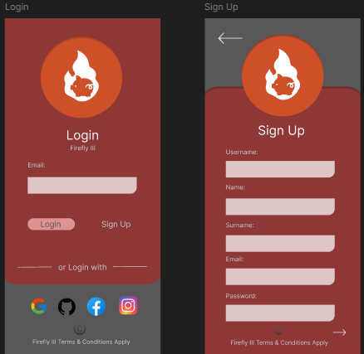

The home Screen provides users with an overview of their financial status, displaying total balance, recent transactions, and progress towards budgeting goals. A clean and organized layout will allow users to quickly look at their finances.

Settings & Profile: Personalization options, security settings, and app preferences.

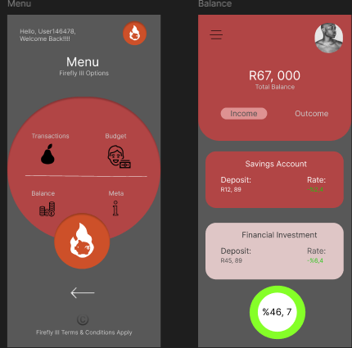

**Budgeting Screen:** This section offers a visual representation of expenses compared to allocated budgets, with charts and graphs to show spending patterns.

**Reports & Analytics:** Users gain deeper insights into their financial habits through detailed reports and analytics. Graphs and charts show income and expenses trends over time.

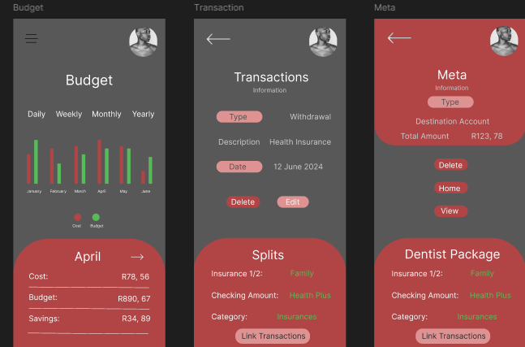

A flowchart that will illustrates how users navigate between different sections of the BudgetMaster app:

1. Login/Sign-up Screen → Leads to Home Screen
2. Home Screen (Displays balance, transactions, and budget progress)
3. Expense Entry Screen (Add new expenses, categorize, attach receipt)
4. Budgeting Screen (Set and manage monthly budgets)
5. Reports & Analytics (Graphical financial insights)
6. Settings & Profile (Personalization, security, and preferences)
7. Sync Status (Shows offline mode and last sync time)
8. From Expense Entry Screen → Redirects back to Home Screen
9. From Reports & Analytics → Users can filter insights and return to Home Screen
10. Settings & Profile → Allows updates and returns to Home Screen

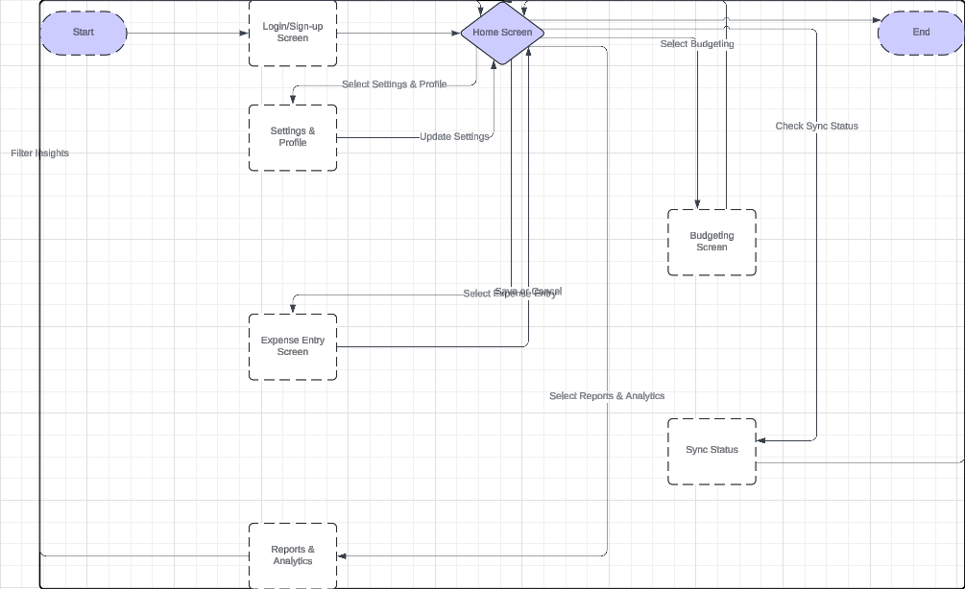

1. Home Screen:
2. Top section: Total balance and recent transactions.
3. Middle: Progress bars for budgeting categories.
4. Bottom: Navigation menu (Home, Expenses, Budget, Reports, Settings).
5. Expense Entry Screen:
6. Fields: Amount, Category, Date, Notes.
7. Upload section for receipt attachment.
8. AI suggestions for categories.
9. Save and Cancel buttons.
10. Budgeting Screen:
11. Monthly budget allocation.
12. Visual charts (bar/pie) for expenditure tracking.
13. Alerts for overspending.
14. Reports & Analytics:
15. Line graphs for spending trends.
16. Filters for custom date ranges.
17. Budget vs. actual comparison.
18. Settings & Profile:
19. Profile picture and username.
20. Security settings (MFA, password change).
21. Sync status and last backup time.

**PROJECT PLAN**

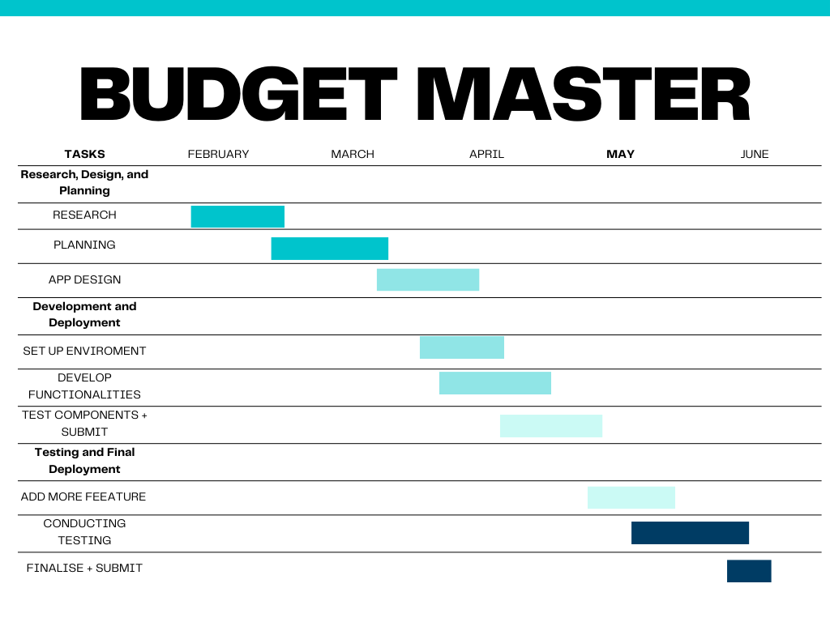

**Conclusion**

​Completing the planning and research phase has provided a solid foundation for developing the personal finance app. By understanding user needs and analyzing existing financial applications, I identified essential features and ways to differentiate the app. Creating detailed prototypes helped visualize the design and functionality, allowing for improvements to ensure the app is user-friendly and effective. This groundwork prepares me to build an app that will help users manage their finances better.

**References**

Firefly III Documentation, [Online] Available at: <https://firefly-iii.org/> [Accessed 26 March 2025].

UX/UI Best Practices, [Online] Available at: <https://uxdesign.cc/> [Accessed 26 March 2025].

Google Material Design Guidelines, [Online] Available at: <https://material.io/design/> Personal Finance Research Articles: [Various sources], [Accessed 26 March 2025].

Figma. (n.d.). Figma design tool, [Online] Available at:  [https://www.figma.com](https://www.figma.com/) [Accessed 26 March 2025].

Mozilla Developer Network (MDN). (n.d.). JavaScript documentation, [Online] Available at: [https://developer.mozilla.org](https://developer.mozilla.org/) [Accessed 26 March 2025].

W3C Web Accessibility Initiative (WAI). (2018). Web Content Accessibility Guidelines (WCAG) 2.0. [Online] Available at:<https://www.w3.org/WAI/WCAG20> [Accessed 26 March 2025].

Codecademy. (n.d.). Learn Node.js interactive tutorial. [Online] Available at:<https://www.codecademy.com/learn/learn-node-js> [Accessed 26 March 2025].

Pressman, R.S. & Maxim, B.R. (2020). Software Engineering: A Practitioner's Approach. 9th edn. McGraw-Hill Education. Nielsen, J. (1993). Usability Engineering. Morgan Kaufmann.